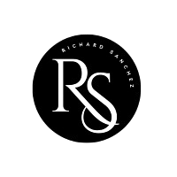

INFORMATION SECURITY STATEMENT

Classification: Public

As part of our mission to [insert company mission], the **TechSolutions Inc.** handles privileged information about our signatories. The information we hold needs to be treated with care and respect regardless of its physical or electronic format.

The TechSolutions Inc. has legislative, moral and contractual responsibilities to ensure that we protect all information adequately. Through designing for security, establishing policies and training, we can help protect the information we handle against various growing information security threats.

The security controls implemented to safeguard the information should mitigate threats to prevent harm from coming to those we are assisting and ensure we can continue to provide first-class services.

The TechSolutions Inc. has produced a series of policies that guide us in operating at the highest standards when securing information. They will also help demonstrate to our clients that we operate with integrity and accept that we are accountable for protecting the information entrusted.

The policies created are based on the following fundamental security principles.

* **Confidentiality** – Protecting information from unauthorised disclosure.
* **Integrity** – Protecting information from unauthorised or erroneous modification.
* **Availability** – Ensuring that information and associated services are available when and where required to meet the [COMPANY NAME]'s service needs.

The policies apply equally to all staff or contracted parties accessing information or information processing systems. The TechSolutions Inc. will ensure that all users are issued with the appropriate policies, can access them easily and understand the importance of adhering to them

The policies will be reviewed and updated to meet the changing business requirements.

**Date**

NAME & SIGNATURE OF SENIOR MEMBER OF STAFF

_____________________________________